Infosys Response for Adobe Review comments.

Table of Contents

Recommnedations – Infosys response 1

Content Architecture 1

SEO consideration – page Metadata 2

Tag Taxonomy 2

Physical Architecture – Pre-Prod setup 2

Recommendation – 5 2

SSO Enabled 2

E-commerce integration – Product catalog strcuture 3

Custom workflows 3

Recommendation – 9 3

Templates and Components 4

Sites- templates/components – Header/Footer configarations 4

Configuration Management – Template policies 4

Site Design Architecture 4

Folder Organization 4

Dynamic rendition of images 4

Git Branching 4

Sonar quality profiles 4

Secuirty Guidelines – Helath Checks are failing 5

Recommendation – 5 Screenshots 5

Recommendations – 9 - Maintenance Dashboard Screenshots 7

# Recommnedations – Infosys response

|  |  |  |  |
| --- | --- | --- | --- |
| **SL#** | **Recommendations** | **Infosys Response** | **Priority as per Infosys Assessment** |
| 1 | Content Architecture | * There was no such requirments from client to have multilingual webiste,Hence MSM strcuture was not considered. * Language root will be implemnted,it’s a small change. | * Please revise the Priority from Medium to Low. |
| 2 | SEO consideration – page Metadata | * Requested M1 to Provide the SEO details at the time of sprint 7 develpoment itself. * This is a known issue to M1. | * Please revise the Priority from Medium to Low. |
| 3 | Tag Taxonomy | * Requested M1 to Provide the SEO details at the time of sprint 7 develpoment itself. * This is a known issue to M1. | * Please revise the Priority from Medium to Low. |
| 4 | Physical Architecture – Pre-Prod setup | * It was highlighted to M1 in the Sprint 7 itself to have Preprod environment, which would be very identical to Prod env. * It’s a known issue to M1 | * Please revise the Priority from Medium to Low |
| 5 | Recommendation – 5 | 1. Admin credentials is not used by everyone. It is used by Admins only. 2. For other people we have created user account for them with required access. 3. For M1 users also, we have a user group M1-Authors and we are creating user account with authors group or administrators group as requested 4. Based on the future request from M1 the ACL will be enhanced. 5. Now requirments from M1 is not clear on this. | * Recommendation to be corrected/removed |
| 6 | SSO Enabled | 1. It is already implemented in SIT/UAT/PROD Author | Recommendation to be corrected/removed |
| 7 | E-commerce integration – Product catalog strcuture | 1. AEM level configuration changes (Catalog path changes) 2. UI level configuration changes will be verified. 3. It’s a small change. | Please revise the Priority from Medium to Low. |
| 8 | Custom workflows | 1. These workflows will be used very rarley, only in case of change in data at backend system. 2. It’s a Demand based, not on regular basis. 3. It is not really necesay but nice to have feature. | Please revise the Priority from Medium to Low |
| 9 | Recommendation – 9 | 1. Maintenance tasks were configured during server setup itself and it is running successfully in all environments as per maintenance dashboard. 2. Weekly Maintenance Tasks    1. Workflow Purge    2. Audit Log Purge    3. Version Purge (Retaining 12 version as communicated earlier)    4. Datastore Garbage Collection 3. Daily Maintenance Tasks    1. Revision Cleanup (Online Tar Compaction)    2. Lucene Binaries Cleanup   Note- Please refer to the screenshots. | To be Corrected/removed from Recommendation list |
| 10 | Templates and Components | * Titles are authorable and this is a small change * We have followed adobe recommended strcuture as per we-retail site. | Please revise the Priority from Medium to Low |
| 11 | Sites- templates/components – Header/Footer configarations | * Implemenattion was done on top of adobe provided AEM SPA Archetype Package, that was not using header/footer fragments. * Content/Expericne fragments are nice to have features | Please revise the Priority from Medium to Low |
| 12 | Configuration Management – Template policies | * As it’s a Agile Projects,changes were done on regular basis for same page/template. * This Policies will be configured once Develpoment is completed. | Please revise the Priority from Medium to Low |
| 13 | Site Design Architecture | * We will work on this. |  |
| 14 | Folder Organization | * Folder strcuture is in place. * During initial development pahse these images were uplaoded for testing purpose. * We will remove the unused assets. | Please revise the Priority from Medium to Low |
| 15 | Dynamic rendition of images | * M1 had procured the Dynamic media license,we will be using the same in upcoming sprints. | Please revise the Priority from Medium to Low |
| 16 | Git Branching | * This will be auto Simplified, once all parallel tracks development is done. | Please revise the Priority from Medium to Low |
| 17 | Sonar quality profiles | * We will work on this, due to time crunch it was not taken up. |  |
| 18 | Secuirty Guidelines – Helath Checks are failing | * This is already in place in SIT/UAT/PROD. * SSL issue is known to M1 and we are working with M1 infra team. | Please revise the Priority from Medium to Low |
|  |  |  |  |

***Adobe’s recommendation Reference*** :



.

### Recommendation – 5 Screenshots

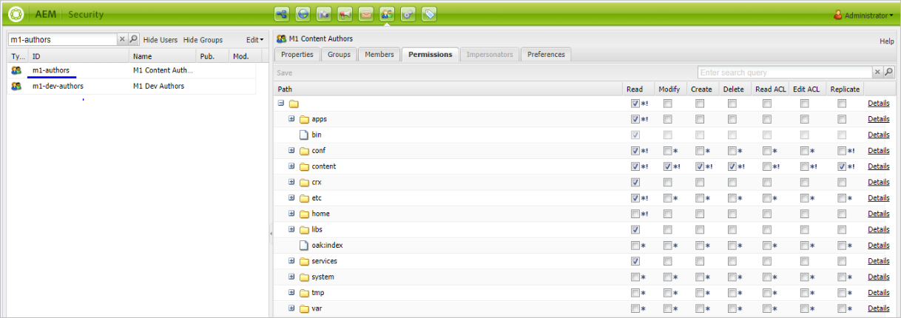

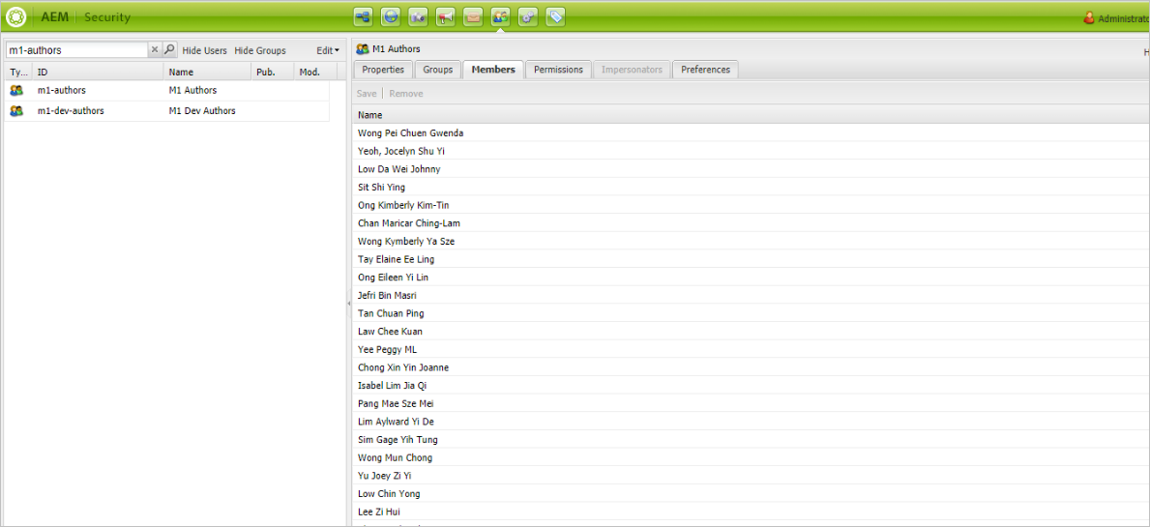

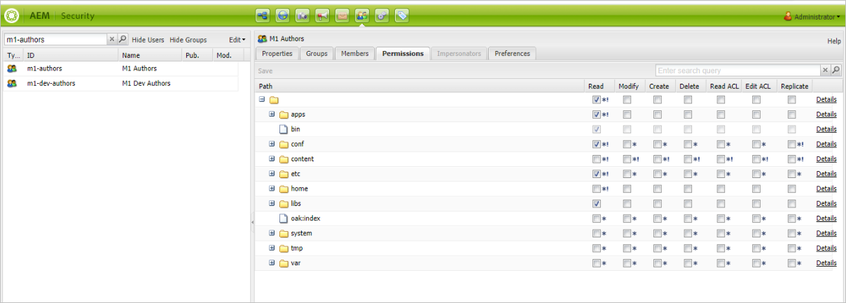

### Recommendations – 9 - Maintenance Dashboard Screenshots

#### PROD Author

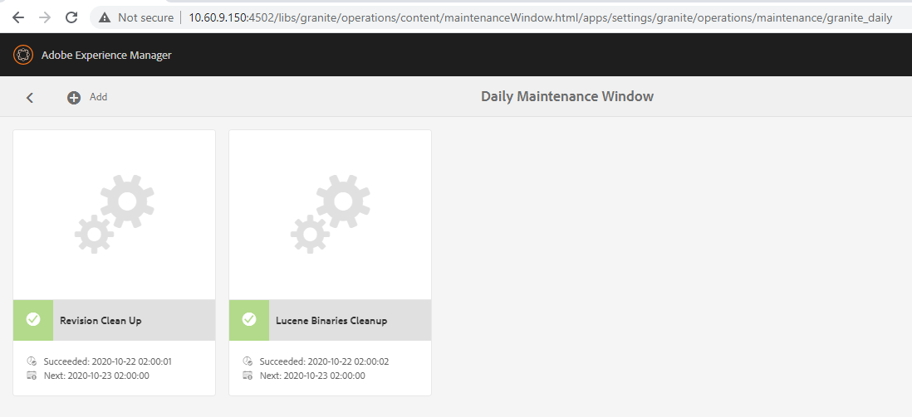

#### PROD Publish 1

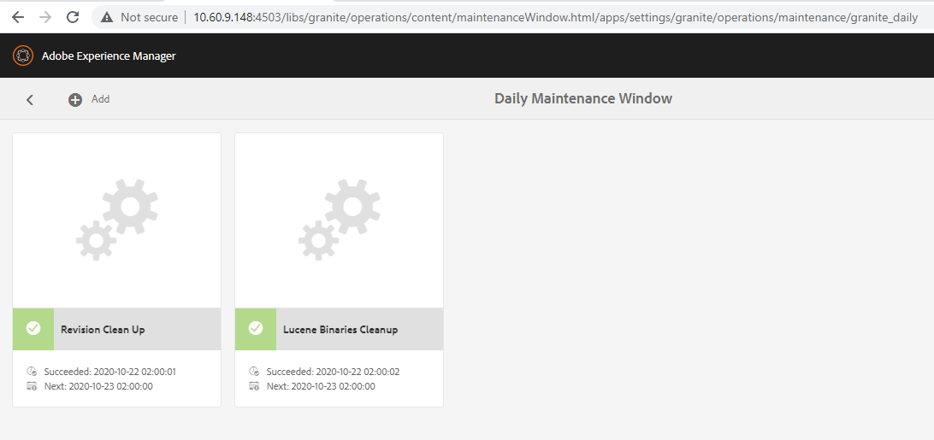

#### PROD Publish 2

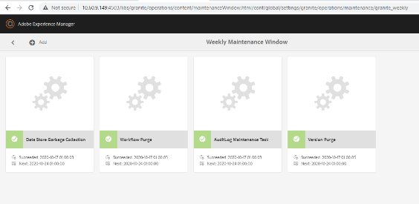

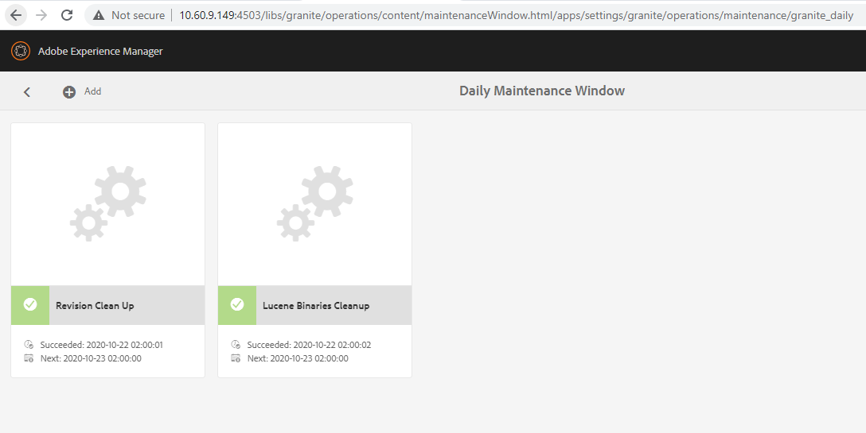

#### UAT Publish

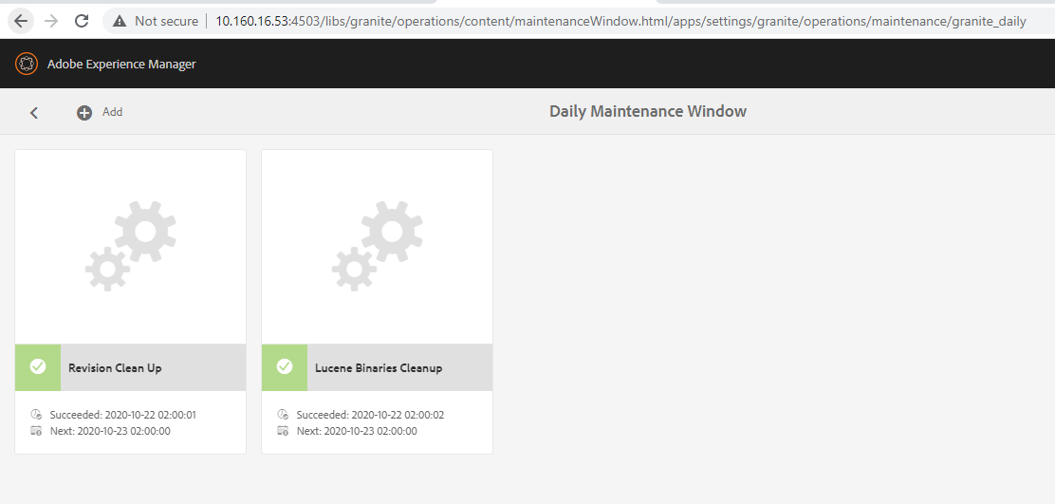SIT Author

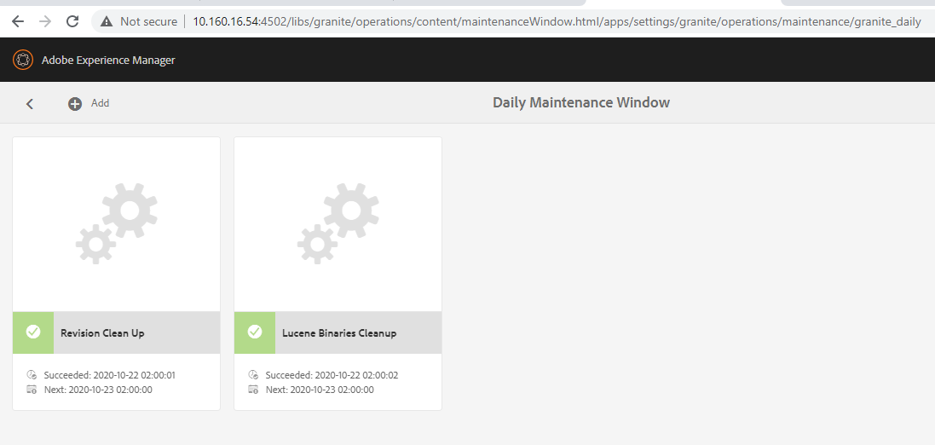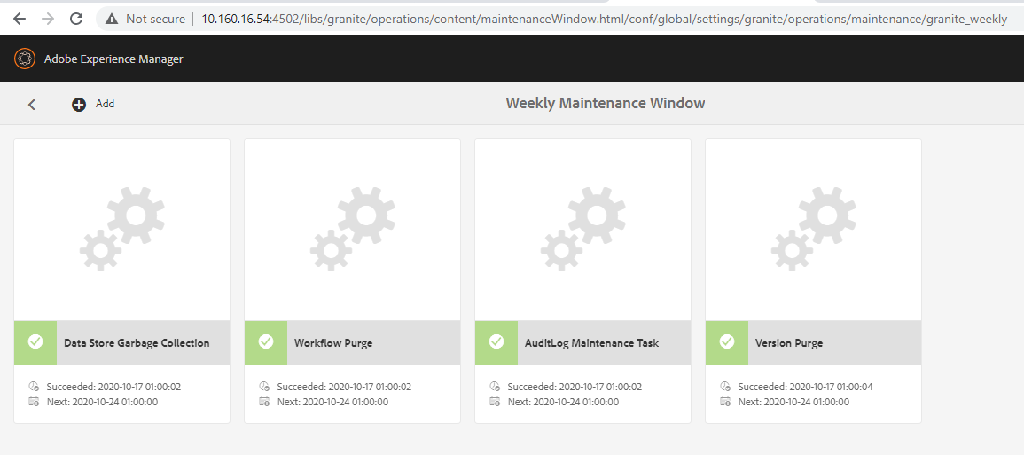

#### SIT Publish

